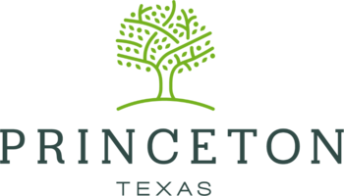
PUBLIC MEETING
Residents are encouraged to consider attending our Tele-conference
Economic Development Corporation meeting on Monday, February 1, 2021 @6:00 p.m. via teleconference.
EDC Meeting
Monday, February 1, 2020 @6:00 PM
Please join my meeting from your computer, tablet or smartphone.
https://global.gotomeeting.com/join/967719989
You can also dial in using your phone.
United States (Toll Free): 1 866 899 4679
United States: +1 (571) 317-3116
Access Code: 967-719-989

